# How to send data from Raspberry Pi to an Android app

The 3 main ways of sending data is usually via a wired connection (ethernet, USB), a wireless connection (WIFI) or the conventional Bluetooth. The benefits of each are outlined within this report.

## Wired Connection

This is usually seen as mainly using an ethernet connection however as it’s from a phone and a Raspberry Pi this wired connection would usually be in the form of a USB cable, many phones use Micro USB to USB cables to connect a phone to other devices. In our case the Pi will have a USB to Micro USB connection. A Flash drive to connect to either the phone or Pi transfer the data to the flash drive then move it to the other medium, is another option.

### Advantage

* More secure as data can’t be intercepted especially using a USB to Micro USB cable
* Speeds are usually faster over a wired connection than wireless
* Drag and drop files or easy to move without too many processes to go through

### Disadvantages

* Both phone and Pi must be in same location as each other can’t be done remotely
* Can’t be used by multiple users who may have phone but not near the Pi
* Can’t send data to other places maybe another phone or Pi

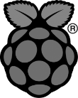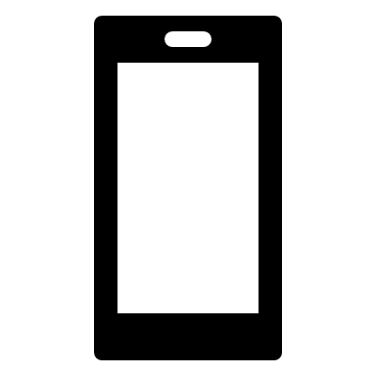

**Phone**

**Sensor**

**Wired Connection USB – Micro USB**

## Wireless Connection

### WFI Connection

This method is mainly using WIFI, either the Raspberry Pi or the phone will act like a WFI hotspot allowing the other device to connect and transmit data.

### Advantage

* Main advantage over other is don’t have to be in same location as the device
* Don’t have to carry around a wire such as a USB to need to send data over
* Can have more than one person sending data as not bound by amount of ports available to you.

### Disadvantages

* Isn’t as secure as wired connection so data could be intercepted by someone else
* Connection can be obstructed by things such as thick walls or everyday household items

## Bluetooth Connection

Bluetooth is a similar method to a wireless connection as it doesn’t require wires however data is usually exchangeable over short distances, using a special radio frequency to transmit data, it creates a short-range network.

### Advantage

* No need to use wires like wireless connection.
* Very secure as connection only between you and the device connected to.
* Can have more than one device connected and up to around 8 devices can be connected on a single connection.

### Disadvantages

* Even though wireless still have been be around the device around 100m so more than usual wired connection.
* Bluetooth isn’t very battery efficient even latest version can still drain a lot of battery.
* Can’t send many big files and can also be very slow sending medium/large files.



**Phone**

**Sensor**

**Wireless connection either via WIFI or Bluetooth**

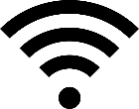

## Conclusion

Overall, I do believe using a wireless connection be it Bluetooth or WIFI is better to use to send data from the Raspberry Pi to the Android app than using a wired connection (USB cable). Wireless connection allows you to be anywhere and can send data which is a big plus over a wired connection even if it’s less secure however, this can be overcome by encrypting the data before it is sent. I am still unsure on which wireless connection is better, Bluetooth or WIFI, as I yet to see how both would be used in this case and which would be practical though Bluetooth, though wireless you still must be near the device itself. This will have to be seen and tested soon to see which would be the most suitable for us to use.